Bonus:- Text Analysis

Q2. Generate both candidate debate word relation network figures.

Trump

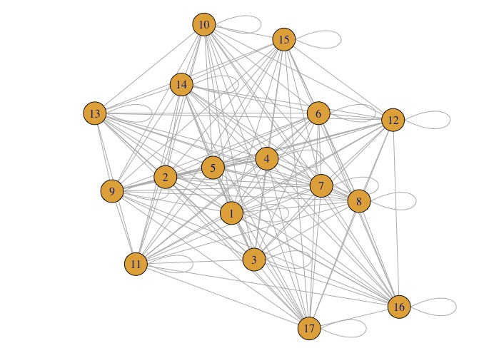

Clinton

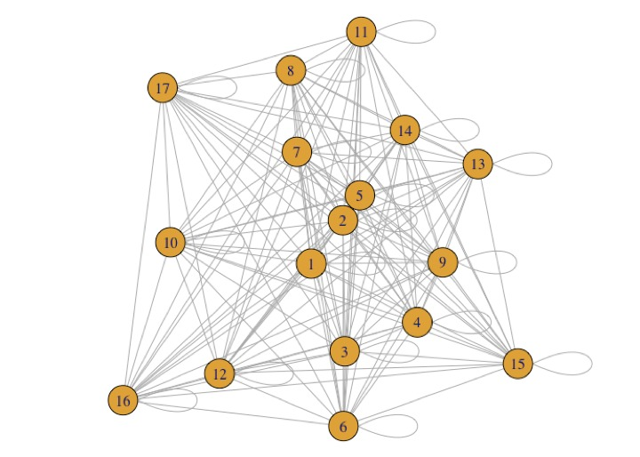

Q3. How do you compare word clouds?

In a word cloud, the larger a word is, there are more occurrences of that word. We can compare two word clouds based on compound words, custom shapes, custom colors, multiple fonts. If we filter the word cloud, we can compare them based on their size and color.

Minimum word limit - 4

Clinton

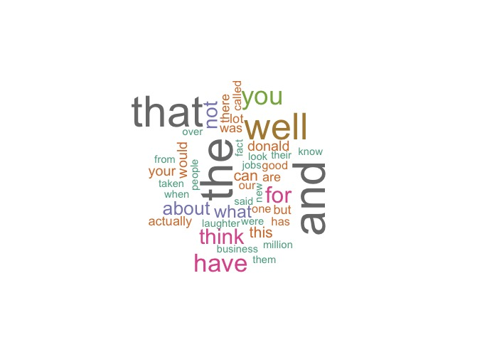

Trump

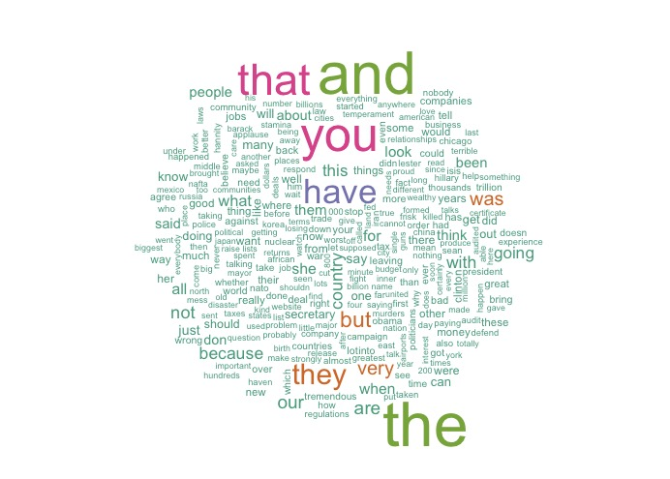

Clinton’s word cloud is smaller than Trump’s.

In Clinton’s word cloud, some of the commonly used words (apart from the basic phrases in the English language are)

* Donald
* Jobs
* Millions
* fact

In Donald Trump’s word cloud, the commonly used words are :-

* people
* country
* jobs
* companies

Q5. What are the candidate’s sentiment analysis scores?

Trump

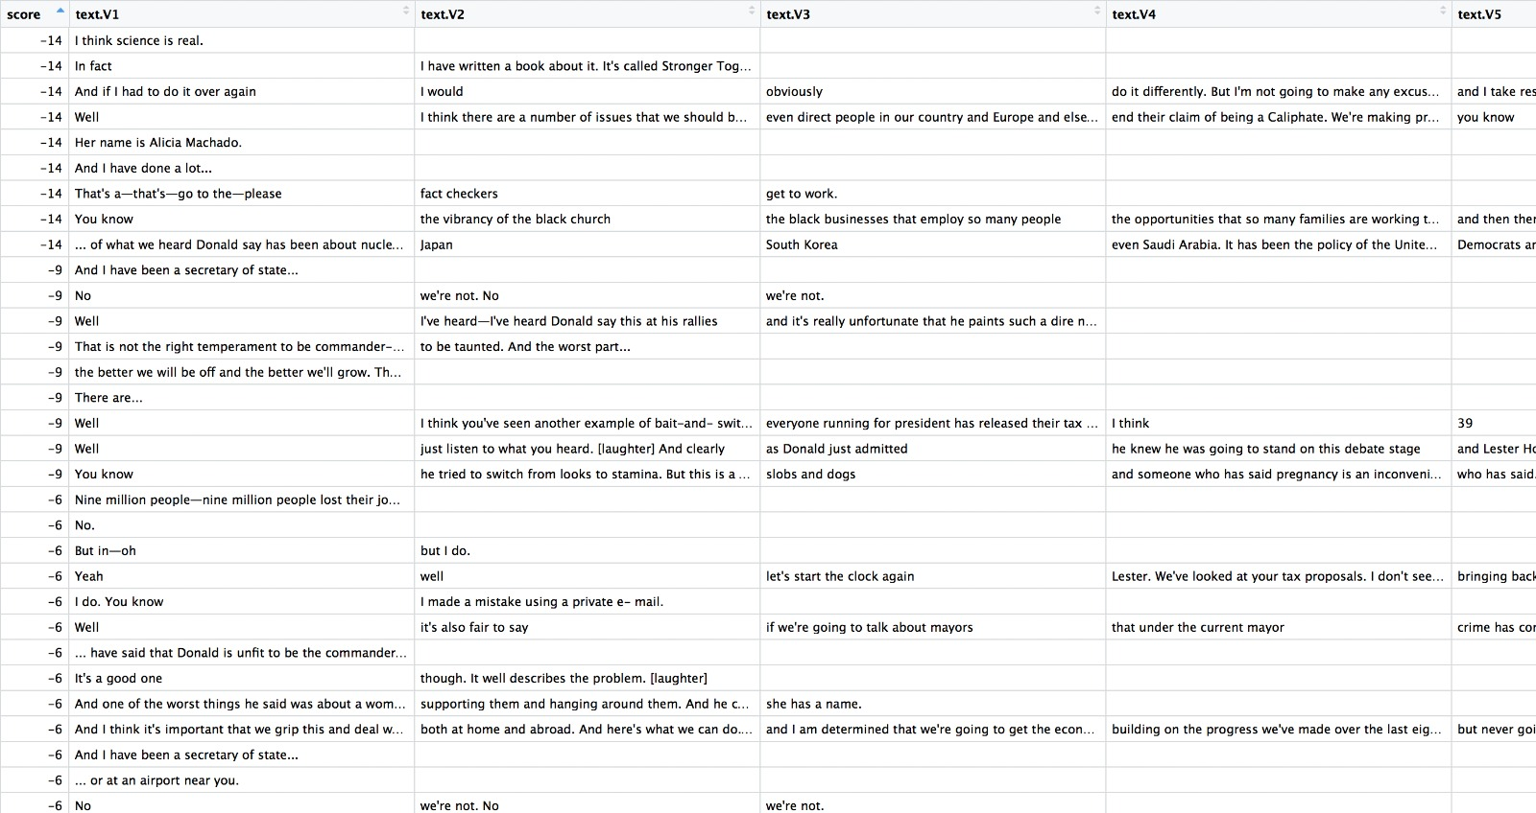

Clinton

